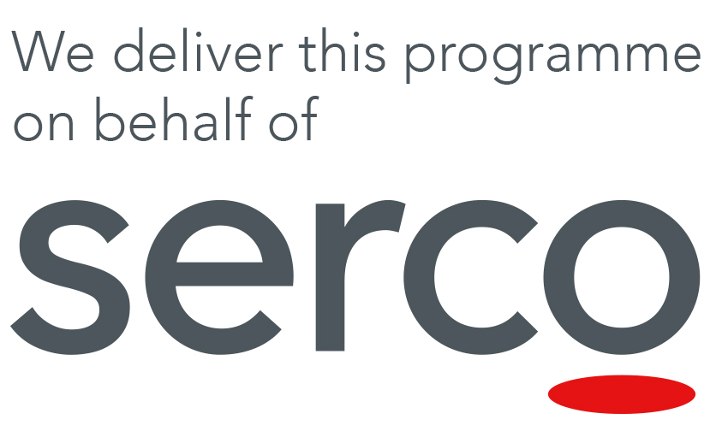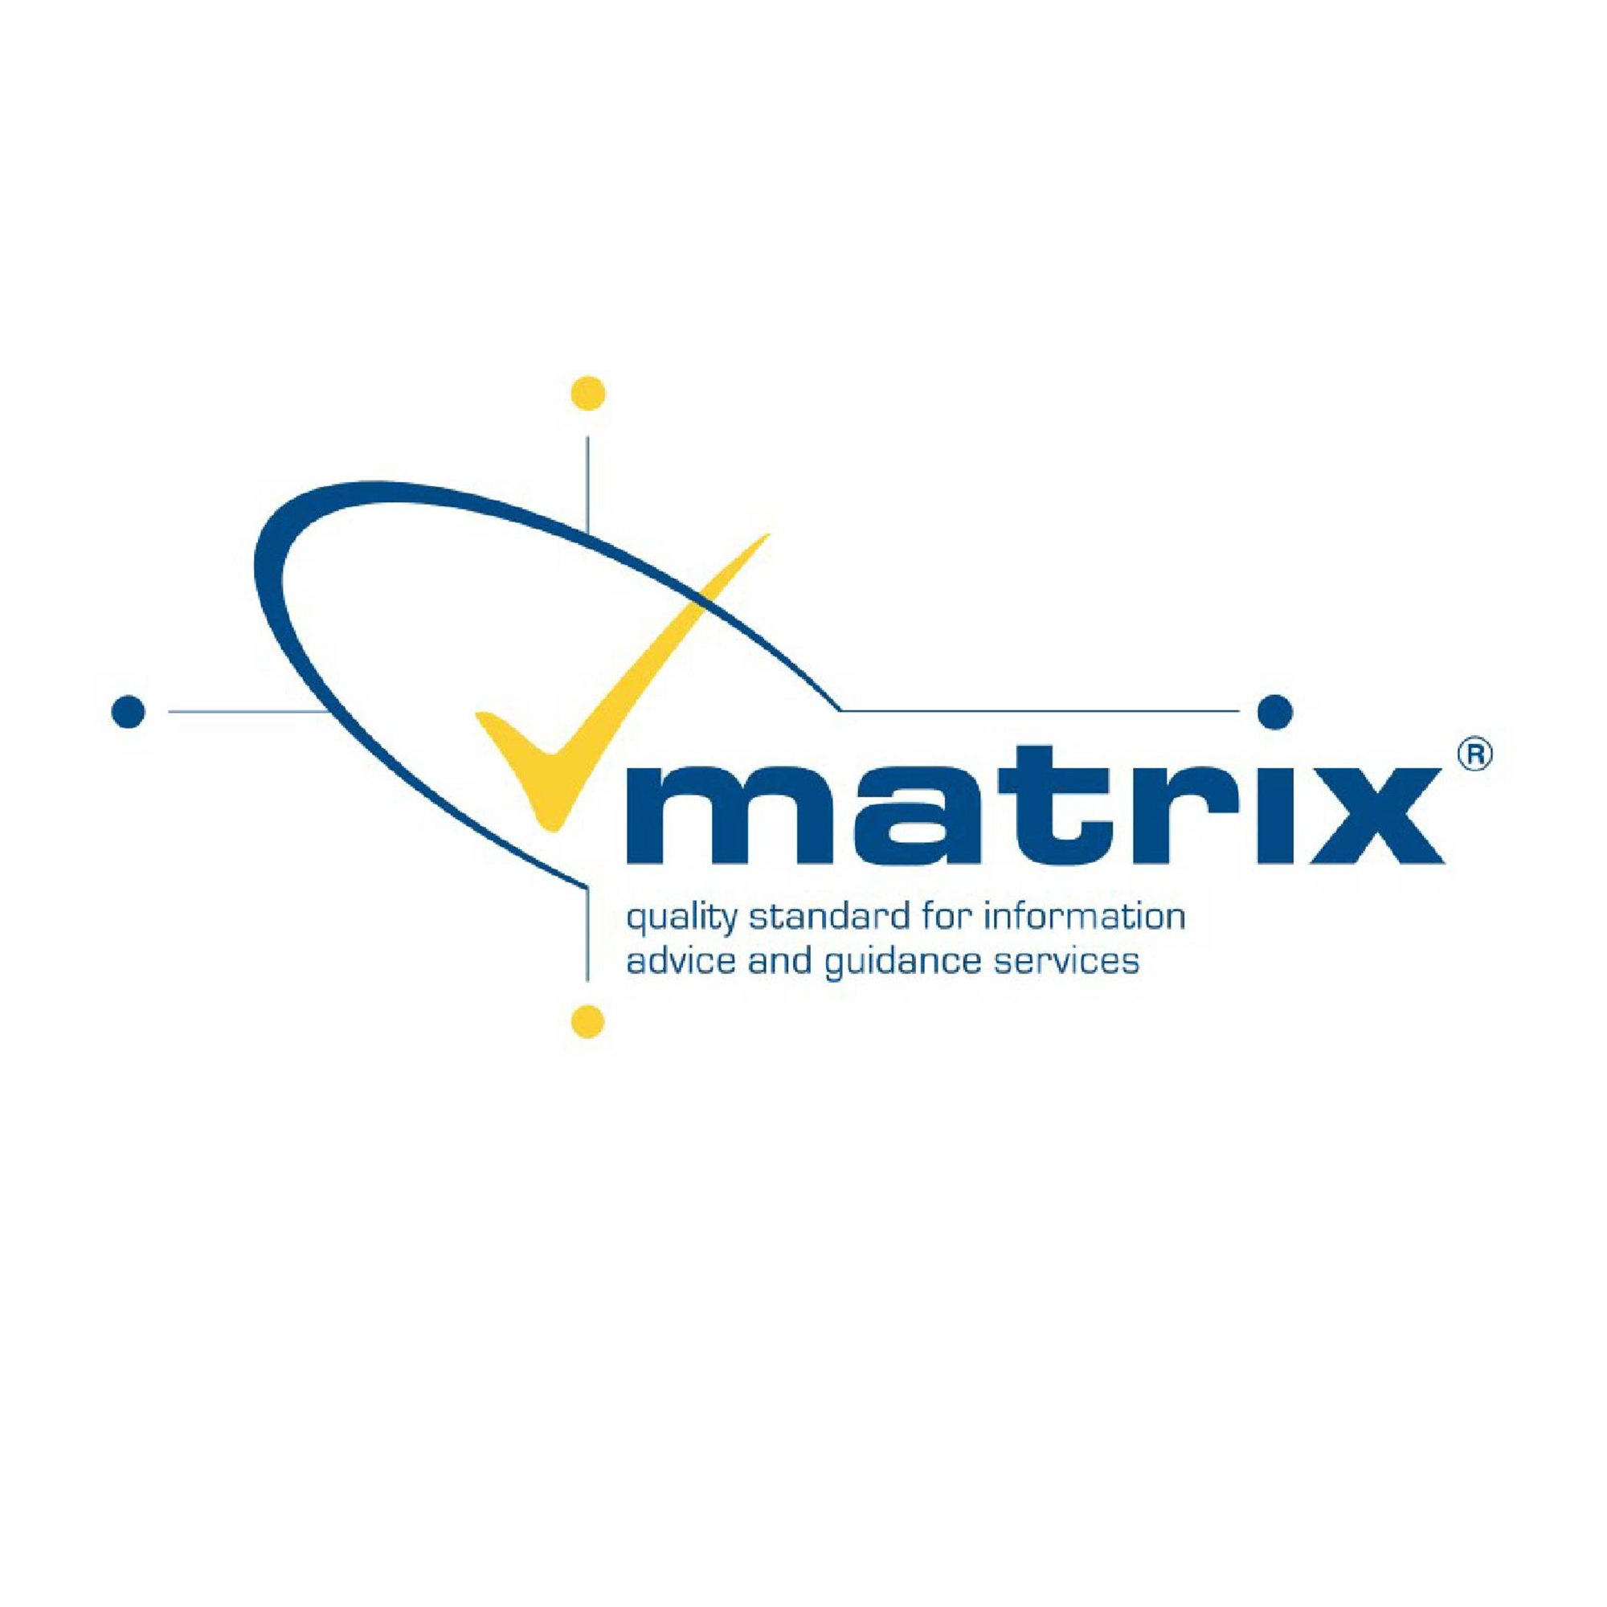
Skills Support for the Workforce – Black Country
IMPROVE GROW TRANSFORM

Do you run an SME in the Black Country or a stone’s throw away? Gecko Programmes Ltd have access to funding to help boost and grow your business at no cost to your company.

We offer recognised accredited qualiﬁcations and bespoke training courses to enhance your employees’ skills in a range of subjects, including Management and Leadership, Mental Health in the Workplace, Information Advice and Guidance, Mentoring, Business Planning, Pricing and Costing, Social Media, Branding and Marketing and many more.

With a long history of commercial and funded B2B training across the LEP for both household names and local Social Enterprises, Gecko are the natural choice to help develop, manage and deliver your SME’s training strategy, and even help develop it.

Enclosed are details of the qualifications we can offer through our various awarding bodies, and also the “Masterclasses” we have developed over the years and in consultation with local businesses.

We can work together to complete a full Training Needs Analysis, creating a bespoke package and training plan for your business that is built around the individual needs of your staff, your business and your plans for growth. We have the capacity to grow both our non-accredited and accredited delivery in-line with your business needs, creating new programmes to exactly match your needs.

All courses can be run to a timetable that causes minimal disruption to the day to day running of your business, which can be delivered on your premises if appropriate.

Accessing the support available is easy, simply use the contact details below to let us know the support you need, or the course(s) you are interested in, and we will be in contact to discuss the next steps:

Jay Hunting – Quality and Curriculum Manager
jay.hunting@geckoprogrammes.co.uk
07456 503491

“Masterclasses”

Mental Health in the Workplace

This 2-Day Masterclass will enable employees to not only recognise, understand and proactively support people to combat the stigma, impacts and risks of Mental Health disorders, but also to develop SMART actions to improve the capacity of your business to reduce the impact they can have.

With advice on developing systems to reduce with the causes of mental unwellness, the impact Mental Health disorders can have on your businesses productivity can be reduced, whilst also offering employees the support, advice and signposting they need.

Social Media and Marketing

This 3-Day Masterclass will give employees an understanding of how marketing works to build and sustain a business’ growth and reputation, and how this links to the digital landscape. Leaners will develop a clearer ability to manage the social responsibility impact of the brand, as well as the capability to understand the resources and policies needed for a responsible digital strategy.

With advice on how to develop an improvement plan to better position your brand in the digital marketplace, and better respond to the everchanging digital landscape, employees can quickly gain the knowledge needed to make the most out of Social Media.

Mentoring

This 3-Day Masterclass will teach employees what it takes to be a mentor, what makes up the practice mentoring and where it can be used. Learners will learn to understand how mentoring practise needs to constantly ensure it accepts that life events can impact on a mentoring relationship and how a mentor must accept differences and diversity in their practise.

The second half of the course will look at the actual process of Mentoring, giving employees the help needed to build a model to implement in their own Mentoring at work, including a clear programme of support and encouragement for the mentee. There will also be a focus on how to reflect and improve on own practise.
Branding
This 3-Day Masterclass will help employees gain knowledge and understanding of Branding as a concept, the role of Promotion and the Promotional Mix, and their value to a business. Employees will gain an understanding of varied branding methods, techniques and objectives, as well as how to successfully create and communicate an Action Plan to support the growth of a Brand/Re-Brand.
This course was created in-line with requests from an existing employer to help their marketing team better understand the importance of Branding and Social Media, and better utilize this knowledge to increase the focus placed on the constant, and consistent, use of a strong and planned brand

Business Planning and Development

This 3-Day Masterclass will show employees how to analyse and communicate with Financial data, as well as develop and communicate a strategic planning process.

The first half of the course examines how we produce and analyse financial information and use it to help make decisions concerning our products and prices, which is followed by insight into the role of strategic planning in an organisation, and how internal and external environmental factors can influence this planning process and help identify a new competitive edge.

Leadership and Motivation

This 3-day Masterclass will support employees to understand the benefits, uses and impacts of many varied management styles and techniques, as well as develop an understanding of Motivational Theory, the factors that impact motivation, and the impact high/low levels of motivation can have on your business.

The first half of the course examines an understanding of a team leaders’ role for future progression. The employee will be able to assess the likely benefits and impacts of different leadership styles and techniques, and the impact of their own leadership on your business, whilst the second half of the delivery will focus on how to motivate and nurture performance across your teams.

Event Preparation and Management

This Masterclass will help your employees understand the process of producing a plan for a live event, the importance of contingency plans and keeping records, and how to present and implement a live event plan. It will also show how to identify the hazards and evaluate the risks in the planning and execution of a live event, how to evaluate, prioritise and plan around those risks, and most importantly how minimise all Health and Safety risks through robust planning and management.

The first half of the course examines how to produce and implement plans for live events and using the plan to coordinate activity, while the aim of this second unit is to provide learners with the knowledge, understanding and skills to understand their responsibilities with regards to health and safety in the planning and execution of live events.

Accredited Courses

Mental Health Awareness - Level 2 Award

Information, Advice and Guidance – Level 1 and 3 Awards

Information, Advice and Guidance – Level 2 Awards and Certificate

Leadership and Management - Level 2 Award and Certificate

Leadership and Management - Level 3 Award and Certificate

Mentoring Skills for Working with Young People - Level 1 Award

Mentoring - Level 2 Award

Mentoring Practice - Level 3 Award

Preparing to Work in Adult Social Care - Level 2 Certificate

Marketing and Social Media – Level 3 Award

Principles of Digital Marketing and Research - Level 3 Award

Principles of Marketing and Evaluation - Level 3 Award

Principles of Social Media within a Business - Level 3 Award

Principles of Marketing - Level 2 Award

Principles of Management - Level 2 Award

Functional Skills - English

Functional Skills - Mathematics

Functional Skills - Information and Communication Technology

Principles of Marketing - Level 3 Award

Team Leading - Level 2 Diploma

Customer Service - Level 2 Diploma

Customer Service - Level 3 Diploma

Business Administration - Level 2 Diploma

Business Administration - Level 3 Diploma

Principles of Team Leading - Level 2 Award

Management - Level 3 Diploma

